Trieste Joyce School

University of Trieste,

28 June – 4 July 2009

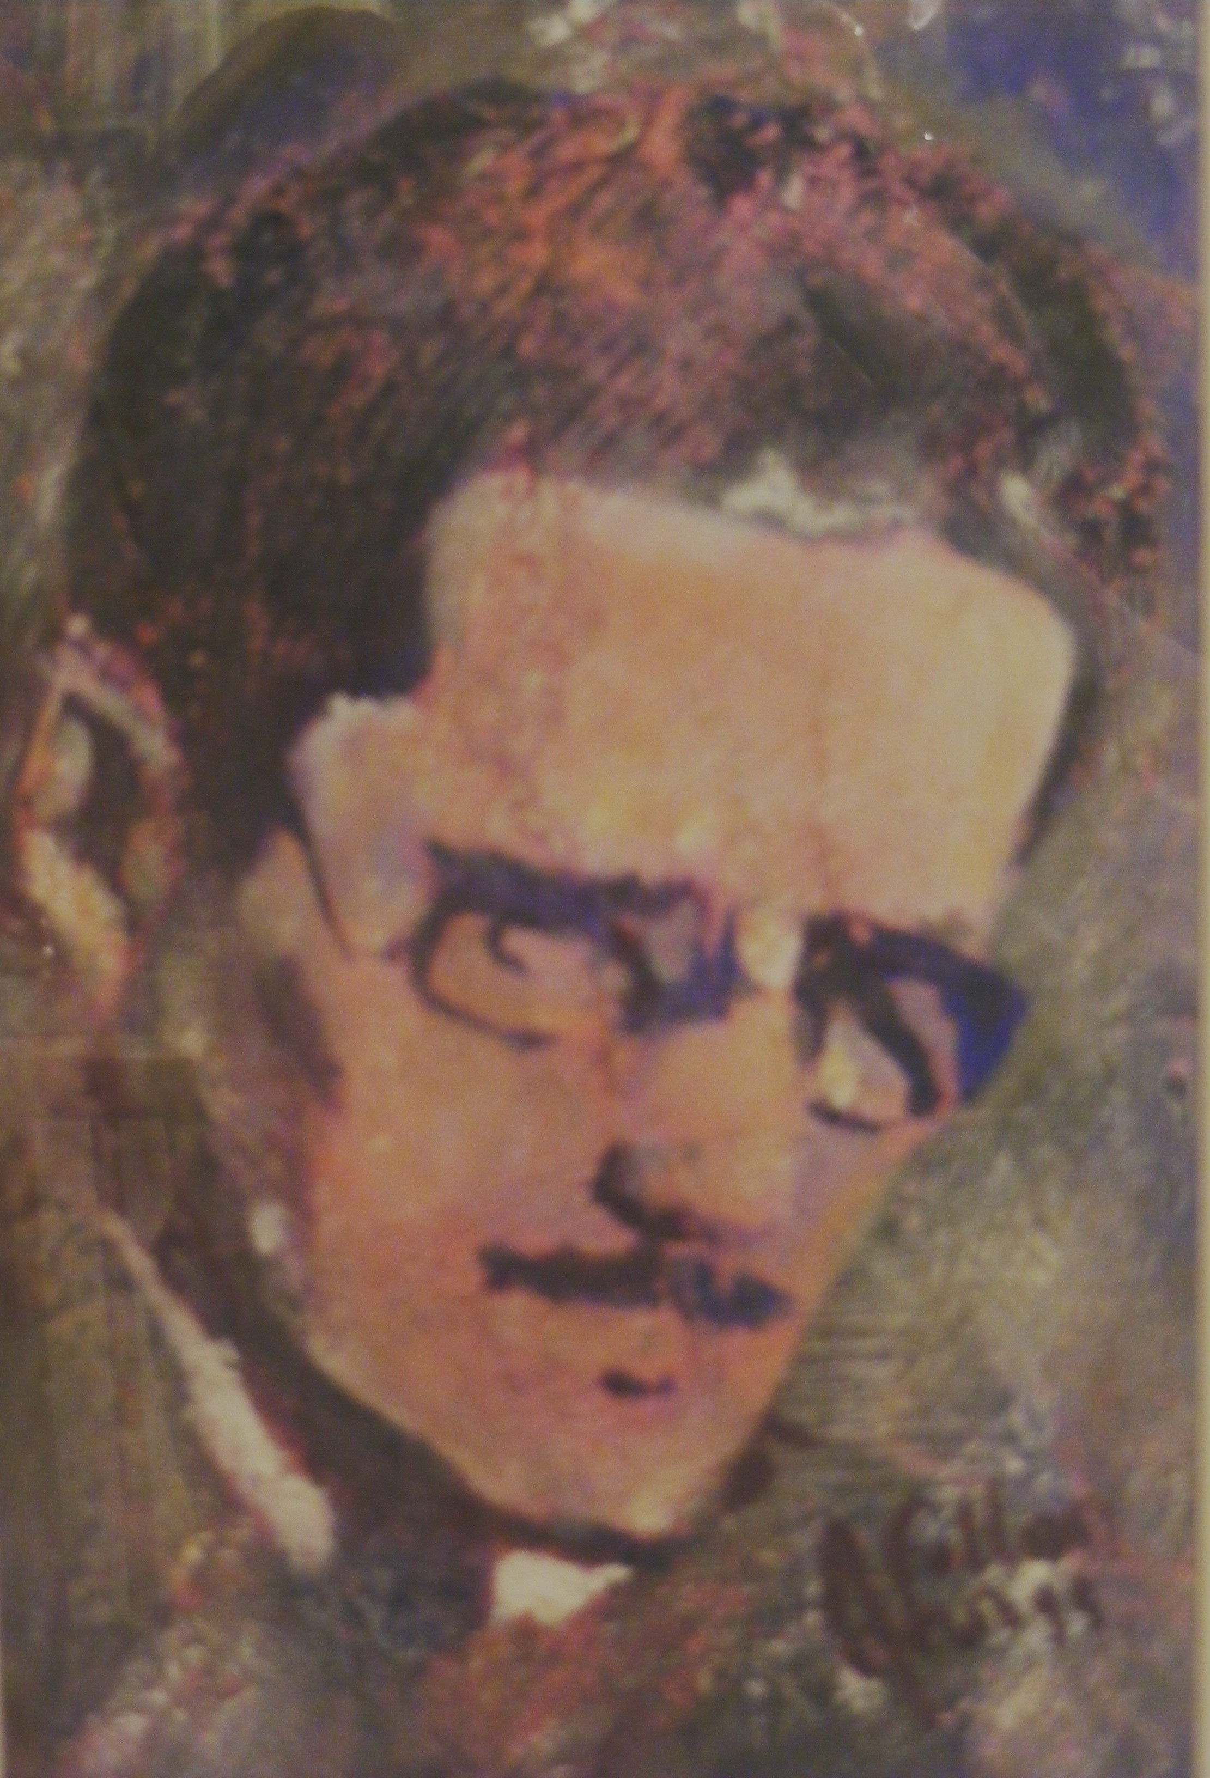

Dipartimento di Letterature Straniere, Comparatistica e Studi Culturali, Università degli Studi di Trieste, Androna Campo Marzio, 10 34123 Trieste

THIRTEENTH ANNUAL TRIESTE JOYCE SCHOOL
28 June-4 July 2009
Lecture Programme
All events will be held in the Auditorium of the Galleria d’arte moderna ‘Revoltella’ on via Diaz 27 unless otherwise stated.

Sunday 28 June
18.30 Opening Reception hosted by His Excellency, Sean Ó hÚiginn, Irish Ambassador to Italy, at the Auditorium of the Galleria d’arte moderna ‘Revoltella’.

Monday 29 June (Auditorium of the Galleria d’arte moderna ‘Revoltella’, via Diaz 27)
9.30: Official Opening
9.45: Laura Pelaschiar: “Joyce’s Spectro-Poetics”
10.30: Tom Rice “Cannibalism and Cultural Transfer, or, James Joyce Learns to Spit.”
12.00: Maria McGarrity "Joyce in the New World: Portrait, Ulysses and the Atlantic Archipelago."

Tuesday 30 June

9.30: Paul Fagan "nat language at any sinse of the world: the Linguistics of 'Wakese'"

10.30: Ilaria Natali “Joyce l’italiano and the Hans Jahnke bequest: preliminary remarks”
12.00: Mark Thompson "Joyce, Danilo Kiš, and the nightmare of history"

Wednesday 1 July

9.30: Geert Lernout "James Joyce and the Trinity".

10.30: Jolanta Wawrzycka “Bonding/Binding; Serving/Severing: Dilemmas of Translation"
12.00: Luke Thurston “Hosts, Guests and Ghosts: from 'The Dead' to the Wake”

Thursday 2 July
9.30: Carlos Gamerro “Joyce and Borges”

10.30: Teresa Caneda "Joyce's Young Man in Havana: Reading A Portrait in Revolutionary Cuba"
12.00: Barry McCrea "Joyce and Proust"

Friday 3 July

9.30: Bill Brockman "'Sincerely yours': Reading Joyce Through His Letters"
10.30: Liliana Ina Gjurgjan “Negative epiphany and Joyce’s Dubliners”
12.00: Fritz Senn “Weaving & Unweaving Leopold Bloom”

Seminars
Seminars are held from 14.30 to 16.00 each afternoon from Monday to Friday at the University.
Dubliners: Tom Rice
Ulysses: Fritz Senn
Portrait: Maria McGarrity
'Beckett (and some Joyce)': Ron Ewart

Participants are expected to register to take part in one of these seminars for the duration of the week.
A seminar on Joyce and Genetic Studies led by Geert Lernout and Ilaria Natali will be held each afternoon at 16.30.

SOCIAL AND CULTURAL PROGRAMME

Monday 29 June, 18.30: Trip to the Osmiza “Milic” in the Triestine Carso. The coach will leave from Piazza Venezia at 18.30 (school members only).

Tuesday 30 June,
18.30: Walking Tour of Joyce’s Trieste with Michela Gandolfo

21.00: Q&A with Mark Thompson, author of A Paper House, a much-praised account of the fall of Yugoslavia and The White War, a history of the Italy-Austria front in the First World War (open to the public at the Museo Revoltella).

Wednesday 1 July, 20.30: Donal O’Kelly performs his highly successful one-man play Jimmy Joyced at the Museo Revoltella (open to the public).

Thursday 2 July, 20.00: Evening of Wine, Pasta, and Song at the Osteria Da Marino. Come prepared to sing! (School members only)

Friday 3 July, 20.30: “At the Cinema with Joyce”: an evening to recollect Joyce’s involvement with the Volta Cinema in Dublin (in collaboration with Alpe Adria Cinema) (open to the public).

The Trieste Joyce School
"Festa del Libro"

Sabato 4 luglio
Sala Maggiore, Camera di Commercio,
Piazza della Borsa, Trieste
L’evento è aperto al pubblico

10.00: Boris Pahor
autore di Necropoli, in conversazione con Miran Košuta (simultaneous translation into English).

11.30: John McCourt
Joyce’s “Irlanda: isola dei santi e dei savi”.
An introduction to Joyce’s 1907 lecture given in the Sala Maggiore of the then Trieste Borsa (traduzione in Italiano).

12.30: Book launch:
A presentation of new books on Joyce (with Marco Camerani, Elisabetta d’Erme, John McCourt, Maria McGarrity, Ilaria Natali, Laura Pelaschiar).

14.30: Barry McCrea
Irish novelist and winner of the 2005 Grumley prize for The First Verse. Introduced by Laura Pelaschiar.

15.30: Carlos Gamerro, scrittore argentino (Las Islas, El sueño del señor juez, El secreto y las). Introduce Ana Cecilia Prenz. In spagnolo, traduzione in italiano e in inglese.

La Trieste Joyce School desidera ringraziare/The Trieste Joyce School wishes to thank: l’Università di Trieste (Ufficio Staff Comunicazione e Organizzazione eventi), Fondazione CRT Trieste, Comune di Trieste, Camera di Commercio di Trieste, CEI (Central European Initiative), Ministero degli Esteri d’Irlanda, Ambasciata d’Irlanda in Italia, Regione Friuli Venezia Giulia, Fondazione Casali, PromoTrieste.

