**JNDs, adaptation, and ambient illumination**

**Giovanni Ramponi**

**IPL, University of Trieste, Italy**

**Rev. June 2021**

We provide formulas and practical results to describe the response of the Human Visual System (HVS) to basic stimuli, especially in terms of the number of Just Noticeable Differences (JND) as a function of the luminance of the display and of the ambient illumination. The observations we make are based on:

* some properties of the HVS,
* the characteristics of the display,
* the viewing conditions, and
* the local properties of the picture.

As far as the display is concerned, we simply suppose that its luminance has a given dynamic range of (*Lmn*, *Lmx*) cd/m2, its horizontal and vertical resolution equals to *hres* and *vres* respectively, and its size equals to *diag* inch. The viewing conditions concern the distance *dist* of the viewer, and the ambient illumination which impinges on the screen and is diffuse-reflected from the same, *Lamb*.

Initial reference: Fig.3 in AAPM On-line Report No.03: “**Assessment of display performance for medical imaging systems: Executive summary of AAPM TG18 report**” – doi 10.1118/1.1861159

(https://aapm.onlinelibrary.wiley.com/doi/full/10.1118/1.1861159)

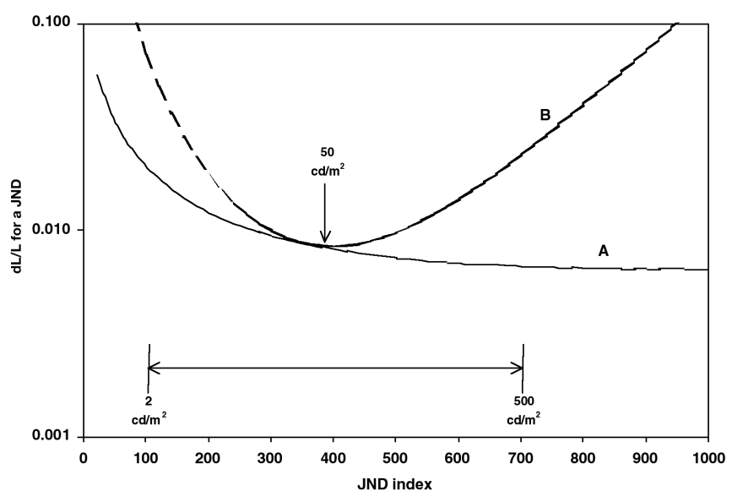

Figure 3. Contrast threshold for varied (A) and fixed (B, Flynn et al. 1999) visual adaptation.

The contrast threshold, ∆L/L, for a just noticeable difference (JND) depends on whether the

observer has fixed (B) or varied (A) adaptation to the light and dark regions of an overall scene.

∆L/L is the peak-to-peak modulation of a small sinusoidal test pattern.

Hypothesis for the following plots: like above, display with [*Lmn, Lmx*] = [2, 500] cd/m2

**Some relevant properties of the HVS**

According to [flynn et al. 99], the human photoreceptor response can be effectively approximated by

*P(L,S) = L / (L+S)* (1)

(Naka-Rushton model used also by other authors)



where *L* is the luminance of the stimulus, and *S* is the adaptation status of the HVS (both in cd/m2). *P* shows (in a semilogx representation) a sigmoidal shape; notice that it is a normalized quantity, in the range (0,1). Other slightly different models can be found in the literature (see. e.g. [irawan05], important also for its analysis about time adaptation), and no general agreement has been reached up to now; the rough behaviour of the response is however captured by Eq.1.

The normalized contrast response *ncr*, i.e. the change in the neuronal response due to a relative change in the luminance stimulus, can be derived from the formula above and is

*ncr(L,S) = dP/(dL/L) = (L*S) / (L+S)^2* (2)



In turn, the normalized contrast threshold *nct*, i.e. the relative luminance variation required to perceive one Just Noticeable Difference (JND), is

*nct(L,S) = 1 / ncr = (L+S)^2 / (L*S)* (3)

To get actual, denormalized values for the contrast threshold, a reference parameter is necessary. Let us take for this purpose the contrast threshold in optimal conditions, i.e. the required luminance variation in the perfect adaptation case *L=S*, and call it *cto*. Since

*nct(L=S) = (2S)^2 / S^2 = 4* (4)

the expression for the denormalized contrast threshold is

*ct(L,S,cto) = (cto/4) * nct = (cto/4) * (L+S)^2 / (L*S)* (5)

About the value of *cto* no agreement is found in the literature; on the contrary, very different values are proposed, like 0.01 [barten92] and 0.1 [ferwerda96]. Actually, the two cited papers deal with different experimental settings: the detection of a fixed sinusoidal grating and of a flashing central square respectively. As a first approximation, we can take the value used by Barten for our study, since we deal with static images.

If the output of the display is constrained in the luminance range (*Lmn,Lmx*) cd/m2, an observer can perceive a finite number of gray levels that differ by one JND one from each other. In the hypothesis that the photoreceptors are able to adapt their status to each displayed level (the so-called varied adaptation case), the total number of JNDs, *Njnd*, can be estimated as the largest integer exponent *N* which satisfies

*(1+cto)^N <= Lmx/Lmn* (6)

E.g., if *cto*=0.01, *Lmn*=2 cd/m2, *Lmx*=500 cd/m2, one gets *N* = 554.

In the fixed adaptation case, on the contrary, the contrast threshold is not constant and we should refer to Eq.5. Fig.1 shows the behaviour of *ct* in the three cases *S* = 30, 50, 100 cd/m2.



The total number of JNDs in this case can be estimated as the largest integer *N* which satisfies

*Prod_[k=1,N] ( 1+ct(L(k)) ) <= Lmx/Lmn*

(7)

where  *L(1) = Lmn; L(k+1) = L(k)*(1+ct(L(k)))*

Since *ct* is always larger than *cto*, a smaller number of JNDs are counted with respect to the ideal constant-*ct* case. E.g., *N* = 350 for *S* = 50. In general, Fig.2 shows the behaviour of the total number of JNDs as a function of the adaptation status *S*. These results are also in agreement with those reported in [ward08].



A simple experiment shows the effects of the adaptation status on the contrast threshold:

We use a Brodatz texture image (D84_raffia, 8-bit, 512x512, from USC database). It has (mean, std) = (158.6, 28.6), and its gray levels occupy the range (70, 222).



A linear scaling of this image to (mean, std) = (128, 5) yields gray levels in the range (112, 139).

The visibility of the scaled texture depends on the display and on the viewing conditions.

If other portions of the image in proximity of the point of fixation contain significantly different luminance values, the adaptation status changes: the response of the photoreceptors to the texture in this case becomes poorer. The performance reduction can be quantified by observing (above) how the contrast threshold increases when the luminance of the object is distant from the adaptation status. A reduction in the number of JNDs results.

To study the different situations as far as the adaptation status of the viewer is concerned, let us superpose a ring having a preset homogeneous luminance to the center of the image. The inner radius of the ring is chosen so that, if the viewer fixes the center of the image, the visible portion of the texture corresponds to the foveola (1 deg). The outer radius is set to the size of the fovea (5 deg). We use this compound image for further experiments.

D84, std=5. Ring gray levels: 20, 128, 230



It can be noticed that the central portion of the texture is less visible in the images on the left and on the right.

For a quantitative analysis, we need an estimate of the adaptation status S. To get one in a simple way, avoiding complications coming from the presence of saccadic eye movements, we consider the perceivability of only the central portion of the image that hits the foveola. The adaptation status, on the contrary, is assumed to depend on the light which hits the whole fovea (in the actual computation, the homog. disk only).

[ The central portion of the retina, devoted to attentive vision, is called fovea and occupies only a few degrees in our field of view. Cones are present only in the fovea, while the concentration of rods, large and uniform on the retina, rapidly decreases in the fovea. More precisely, we can distinguish among the fovea itself, having a diameter of 1.5 mm corresponding to 5.2 deg; the rod-free portion of the fovea, with diameter 0.5 mm (1.7 deg); and the foveola (rod-free, capillary-free fovea), with diameter 0.3 mm (1 deg) [wandellxx]. ]

Hypothesized experimental setting: (3 MegaPixel diagnostic grayscale display)

(*Lmn,Lmx*)=(2, 500) cd/m2; (*hres,vres*)=(2048, 1536) px; *diag*=21'';

Let the viewer distance be 50 cm. The widths of the fovea and foveola correspond to 4.36 and 0.87 cm respectively; in pixels, 209 and 42 pixels respectively. The average luminance in the fovea area can be roughly taken as the adaptation status.

In the setting above, considering a *gamma* 2.4 for the display (no DICOM correction for simplicity), the scaled texture yieds luminance values in the range (*L1,L2*)=(71.1,118.1) cd/m2; the adaptation status of the viewer is derived from the display response function (DRF) applied to the average gray level of the image, 128, and is *S*=97.2 cd/m2. Eq.7, with *Lmn* and *Lmx* replaced by *L1* and *L2* respectively, permits to estimate that 51 JNDs exist in this range.

The reduced visibility of the texture in the left and right images is explained considering that *Gr* = 230 brings the adaptation status to 390.8 cd/m2; the new number of JNDs is in this case 32. When *Gr* = 20, *S* is equal to 3.1 cd/m2, and the number of JNDs is 7.

**Ambient illuminance effects**

It should be noticed that the calculations we have performed do not take into account yet the ambient illuminance diffused by the display screen, which adds a luminous input devoid of information.

The effects of such a diffused ambient light can be easily taken into account, by adding a value of *Lamb* to the previous values of *Lmn*, *Lmx*, *S*. The result is twofold: the effective dynamic range is reduced from *Lmx/Lmn* to *(Lmx+Lamb)/(Lmn+Lamb)*, and the adaptation status changes. The reduced dynamic range, in particular, makes the number of JNDs decrease for increasing *Lamb*.

[seetzen06] refers to an ambient illuminance of 100 Lux and a modestly reflective environment, corresponding to an average ambient luminance of about 20 cd/m2. This value is an overestimate when dealing with reading medical images.

The light reflected by the LCD screen itself in a moderately illuminated environment can correspond to a few cd/m2. [ward08] indeed hypothesizes a 1% or 2% screen reflectance and an ambient illuminance up to 200 Lux, which yield up to 4 cd/m2 of reflected light. In a medical reading room with *I* = 30 Lux [AAPM report]

if *Rd* = .02 1/sr (diffuse reflection coefficient), *Lamb* = *I* * *Rd* = 30 * .02 = .6 cd/m2

The AAPM report [Sec. 4.3.4.2.1] requires *Lamb* < *Lmin* / 1.5



We can count the JNDs in the dark part of the range in particular, choosing suitable values for L1 and L2, with Lmn < L1 < L2 < Lmx:

E.g., if S = 50; Lmn = 2; Lmx = 500, no Lamb:

L1 = 2; L2 = 500 --> 350 JNDs

L1 = 2; L2 = 10 --> 50 JNDs

L1 = .1; L2 = 10 --> 58 JNDs

with Lamb = 1:

L1 = 2; L2 = 500 --> 342 JNDs smaller than above, since the effective dynamic range is reduced

L1 = 2; L2 = 10 --> 48 JNDs same comment

L1 = .1; L2 = 10 --> 60 JNDs slightly larger, prob. because the effect of being closer to S is stronger

and ct increases

It should be mentioned that the analysis above has hypothesized a Weber-law response of the HVS. This is a reasonable approximation, but is no longer valid if we make reference to small levels of luminance (below a few cd/m2), where mesopic or scotopic behaviour arises due to the contribution of rods in the retina. The used models should be modified accordingly.

**References**

[wandellxx] B. Wandell, "Useful Numbers in Vision Science", http://white.stanford.edu/~brian/numbers/numbers.html. Accessed May 14, 2009.

[flynn99] M.J. Flynn, J. Kanicki, A. Badano, W.R. Eyler, "High-Fidelity Electronic Display of Digital Radiographs", Radiographics 1999; 19:1653-1669.

[irawan05] P. Irawan, J.A. Ferwerda, S.R. Marschner, "Perceptually-based tone mapping of high dynamic range image streams", 2005 Eurographics Symposium on Rendering, pp.231-242.

[barten92] P.G.J. Barten, "Physical Model for the Contrast Sensitivity of the Human Eye", SPIE vol.1666 Human Vision, Visual Processing, and Digital Display III (1992), pp.57-72.

[ferwerda96] J.A. Ferwerda, S.N. Pattanaik, P. Shirley, D.P. Greenberg, "A Model of Visual Adaptation for Realistic Image Synthesis", *SIGGRAPH 96 Conference Proceedings*, Annual Conference Series, pages 249--258. ACM SIGGRAPH, Addison Wesley, August 1996.

[ward08] G. Ward, "Defining Dynamic Range", Proceedings of the 2008 Society of Information Display Symposium, May 2008.

[seetzen06] H. Seetzen, H. Li, L. Ye, W. Heidrich, L. Whitehead, G. Ward, "Observations of Luminance, Contrast and Amplitude Resolution of Displays", Proc. SID 2006, paper no.25.3.

**MATLAB**

%% photoreceptors, contrast response, contrast threshold, Njnd

Lmn = 2; Lmx = 500; % min and max display luminance

L = linspace(Lmn,Lmx,1000);

cto = .01; % Barten

% figure(1);

for S = [10,50,100]; % fixed adaptation status

P = L ./ (L+S); % photor. response

% h=semilogx(L,P); hold on; grid on; set(h,'LineWidth',1.5); title('response vs. luminance for S=10,50,100');

cr = L .* S ./ (L+S).^2; % (normalized) contrast response = dP/(dL/L)

% h=semilogx(L,cr); hold on; grid on; set(h,'LineWidth',1.5); title('ncr vs. luminance for S=10,50,100');

ct = (cto./4) * (1./cr); % ct, scaled to get ct=cto for L=S;

% h=loglog(L,ct); hold on; grid on; set(h,'LineWidth',1.5); title('ct vs. luminance for S=10,50,100'); axis([1 1e3 .009 .1]);

end;

% hold off;

figure(2);

Lamb = 0; % set Lamb=0,1

L=L+Lamb; Lmn=Lmn+Lamb; Lmx=Lmx+Lamb; %%%%%%%%% beware... !

kk = []; SS = [];

for S = [5:1:300] + Lamb; % fixed adaptation status

cr = L .* S ./ (L+S).^2; % contrast response = dP/(dL/L)

ct = (cto./4) * (1./cr); % ct, scaled to get ct=cto for L=S;

LL = Lmn;

for k = 1:1000000

ind = floor((LL - Lmn) / ((Lmx-Lmn)/1000)+1);

LL = LL * (1+ct(ind));

% LL = LL * (1+cto); % ideal case, varied adaptation

if LL>Lmx, [k, LL, ind, ct(ind)]; break; end;

end;

kk = [kk k]; SS = [SS S];

end;

h=semilogx(SS,kk); grid on; set(h,'LineWidth',1.5); axis([1 1e3 240 360]);

title('Njnd vs. S'); % title('Njnd vs. S -- Lamb=0,1');

% hold on; % to visually compare different Lamb values

%% no. of JNDs in the range L1...L2, with Lamb

Lmn = .1; Lmx = 500; % min and max display luminance

L = linspace(Lmn,Lmx,1000);

Lamb = 0; L=L+Lamb; Lmn=Lmn+Lamb; Lmx=Lmx+Lamb; %%%%%%%%% beware... !

cto = .01; % Barten

S = 50+Lamb; % fixed adaptation state

cr = L .* S ./ (L+S).^2; % contrast response = dP/(dL/L)

ct = (cto./4) * (1./cr); % ct, scaled to get ct=cto for L=S;

L1 = 2+Lamb; L2 = 10+Lamb;

LL = L1;

for k = 1:1000000

ind = floor((LL - Lmn) / ((Lmx-Lmn)/1000)+1);

% [k, LL, ind, ct(ind)]

LL = LL * (1+ct(ind));

if LL>L2, break; end;

end;

k % no. of JNDs in the range L1...L2, with Lmn < L1 < L2 < Lmx