Esempi OCTAVE/MATLAB
Figure 1: sin(x) 1
Figure 2: sin(x) + cos(y) 3
Figure 3: distribuzione Gaussiana 4

octave:1> a=0.5; b=0.5; c=a+b
c = 1
octave:2> sin(c)
ans = 0.84147
octave:3> cos(c)
ans = 0.54030
octave:4> log(c)
octave:5> exp(c)
ans = 2.7183
octave:6> c**2
ans = 1
octave:7> 2**2
ans = 4
octave:11> x=(0.1:0.1:7.3); x'
octave:13> sin(x)'
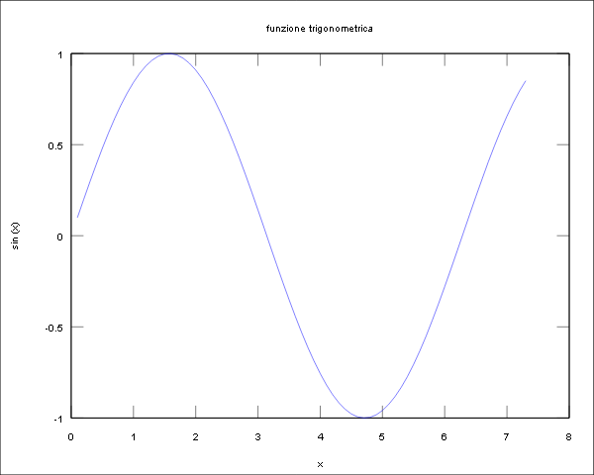
Figure 1: sin(x)

x | sin(x)
0.10000 | 0.099833
0.20000 | 0.198669
0.30000 | 0.295520
0.40000 | 0.389418
0.50000 | 0.479426
0.60000 | 0.564642
0.70000 | 0.644218
0.80000 | 0.717356
0.90000 | 0.783327
1.00000 | 0.841471
1.10000 | 0.891207
1.20000 | 0.932039
1.30000 | 0.963558
1.40000 | 0.985450
1.50000 | 0.997495
1.60000 | 0.999574
1.70000 | 0.991665
1.80000 | 0.973848
1.90000 | 0.946300
2.00000 | 0.909297
2.10000 | 0.863209
2.20000 | 0.808496
2.30000 | 0.745705
2.40000 | 0.675463
2.50000 | 0.598472
2.60000 | 0.515501
2.70000 | 0.427380
2.80000 | 0.334988
2.90000 | 0.239249
3.00000 | 0.141120
3.10000 | 0.041581
3.20000 | -0.058374
3.30000 | -0.157746
3.40000 | -0.255541
3.50000 | -0.350783
3.60000 | -0.442520
3.70000 | -0.529836
3.80000 | -0.611858
3.90000 | -0.687766
4.00000 | -0.756802
4.10000 | -0.818277
4.20000 | -0.871576
4.30000 | -0.916166
4.40000 | -0.951602
4.50000 | -0.977530
4.60000 | -0.993691
4.70000 | -0.999923
4.80000 | -0.996165
4.90000 | -0.982453
5.00000 | -0.958924
5.10000 | -0.925815
5.20000 | -0.883455
5.30000 | -0.832267
5.40000 | -0.772764
5.50000 | -0.705540
5.60000 | -0.631267
5.70000 | -0.550686
5.80000 | -0.464602
5.90000 | -0.373877
6.00000 | -0.279415
6.10000 | -0.182163
6.20000 | -0.083089
6.30000 | 0.016814
6.40000 | 0.116549
6.50000 | 0.215120
6.60000 | 0.311541
6.70000 | 0.404850
6.80000 | 0.494113
6.90000 | 0.578440
7.00000 | 0.656987
7.10000 | 0.728969
7.20000 | 0.793668
7.30000 | 0.850437

octave:21> ang=(0.1:0.1:7.3);
[x, y] = meshgrid (ang, ang);
mesh(x,y,sin(x)+cos(y))

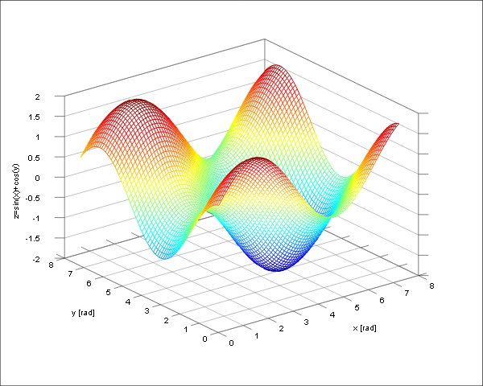
Figure 2: sin(x) + cos(y)

Confronto tra distribuzione numeri random e distribuzione Gaussiana:
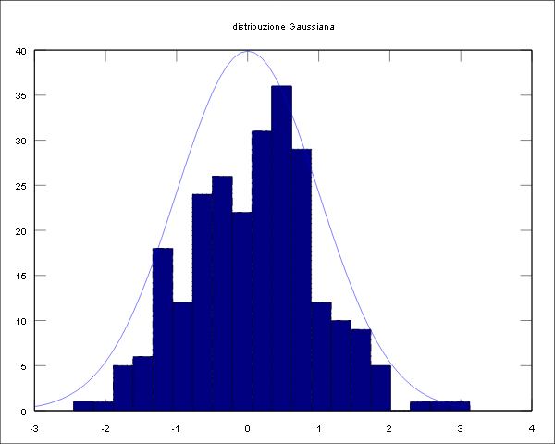
Figure 3: distribuzione Gaussiana

